Lab 1
Adam Satyshev
IT-2302
1. Lab Objectives
By completing this lab, students will be able to:
- Implement a simple RPC protocol in a programming language of their choice (Python, Go, Java, Node.js).
- Understand RPC components: client stub, server stub, marshalling, network transport.
- Deploy a real client–server distributed application on AWS EC2.
- Observe communication failures, retry logic, and behavior under delays.
- Evaluate at-least-once vs at-most-once semantics.
This lab reinforces CLOs:
- Implementing distributed algorithms (RPC).
- Deploying distributed systems on EC2.
- Analyzing communication reliability and failure behavior.
2. What You Will Build
You will implement a minimal RPC system, consisting of:
Server Node
- Exposes one remote function, e.g.:
  - add(a, b)
  - get_time()
  - reverse_string(s)
  - or any simple deterministic function
- Listens on a TCP or UDP socket
- Decodes requests, executes the function, returns the result
Client Node
- Sends remote requests to the server using your RPC format
- Handles:
  - timeouts
  - retries
  - unique request IDs
- Shows result on the terminal
Network layer
- Your own simple request/response structure, e.g. JSON, protobuf, or custom text format
Deployment
- 2 EC2 instances (t2.micro or t3.micro).
- Client on Instance A, Server on Instance B.
- SSH into both, run programs, test RPC calls.
3. Pre-Lab Setup (Required Before the Lab Session)
Step 1 — Create two EC2 Instances
- Launch Ubuntu 22.04 (recommended)
- Name them:
  - rpc-client-node
  - rpc-server-node
- Open port 5000 (or any port you choose) in Security Group inbound rules
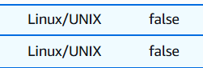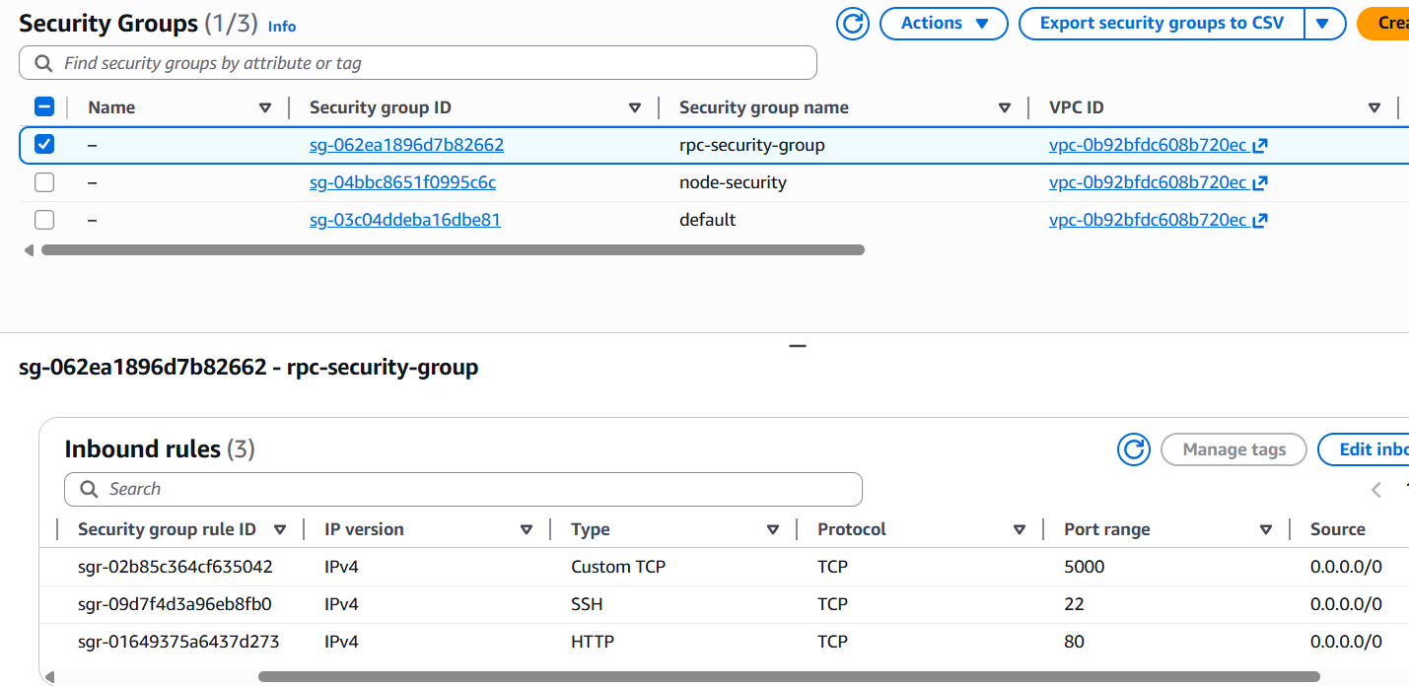
Step 3 — Test Connectivity
From client → server:
ping <server-public-ip>
nc -vz <server-public-ip> 5000
If this works, you’re ready.
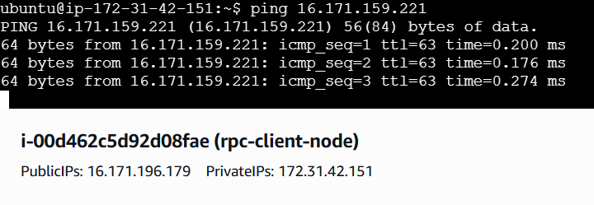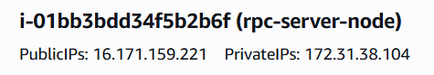
4. Implementation Requirements
✔ Required RPC Message Structure
You must include:
- Request ID (UUID or incrementing)
- Function name (string)
- Arguments (list or dict)
- Timestamp (optional)
Example (JSON):
{
"request_id": "123-abc",
"method": "add",
"params": {"a": 5, "b": 7}
}
✔ Server Responsibilities
- Listen for requests
- Parse incoming JSON
- Execute correct function
- Return response:

{
"request_id": "123-abc",
"result": 12,
"status": "OK"
}
✔ Client Responsibilities
- Send request
- Start timeout timer (e.g. 2 seconds)
- If there is no response:
  - retry the request (2–3 retries max)
- Print final result or error
✔ Error Handling
You must demonstrate one of the following:
- Server intentionally slowed (e.g., sleep 5 seconds)
- Client retries logic triggers
- Lost packet simulation (drop response)
- Server crash scenario
5. Tasks
Task 1 — Implement the RPC client & server
Language options: Python, C++, Go, Java, Node.js
Requirements:
- TCP or UDP sockets (you choose)
- JSON or custom serialization
- One or more remote functions
- Logging for each request
server.py:
import socket
import json
import threading
import time

HOST = "0.0.0.0"
PORT = 5000

def add(a, b):
return a + b

def get_time():
return time.ctime()

def reverse_string(s):
return s[::-1]

FUNCTIONS = {
"add": add,
"get_time": get_time,
"reverse_string": reverse_string
}

def handle_client(conn, addr):
print(f"[SERVER] Connected by {addr}")
try:
data = conn.recv(4096)
if not data:
return

request = json.loads(data.decode())
print(f"[SERVER] Received request: {request}")

if request.get("method") == "add":
time.sleep(5)

method = request["method"]
params = request.get("params", {})
request_id = request["request_id"]

if method not in FUNCTIONS:
response = {
"request_id": request_id,
"status": "ERROR",
"error": "Unknown method"
}
else:
result = FUNCTIONS[method](**params)
response = {
"request_id": request_id,
"status": "OK",
"result": result
}

conn.sendall(json.dumps(response).encode())

except Exception as e:
print("[SERVER] Error:", e)
finally:
conn.close()

def start_server():
with socket.socket(socket.AF_INET, socket.SOCK_STREAM) as s:
s.bind((HOST, PORT))
s.listen()
print(f"[SERVER] Listening on port {PORT}")

while True:
conn, addr = s.accept()
thread = threading.Thread(target=handle_client, args=(conn, addr))
thread.start()

if __name__ == "__main__":
start_server()

client.py:
import socket
import json
import uuid
import time

SERVER_IP = "16.171.159.221"
PORT = 5000
TIMEOUT = 2
MAX_RETRIES = 3

def rpc_call(method, params):
request_id = str(uuid.uuid4())

request = {
"request_id": request_id,
"method": method,
"params": params,
"timestamp": time.time()
}

for attempt in range(1, MAX_RETRIES + 1):
try:
print(f"[CLIENT] Attempt {attempt}")
with socket.socket(socket.AF_INET, socket.SOCK_STREAM) as s:
s.settimeout(TIMEOUT)
s.connect((SERVER_IP, PORT))
s.sendall(json.dumps(request).encode())

response = s.recv(4096)
response_data = json.loads(response.decode())

print("[CLIENT] Response:", response_data)
return response_data

except socket.timeout:
print("[CLIENT] Timeout occurred, retrying...")
except Exception as e:
print("[CLIENT] Error:", e)

print("[CLIENT] RPC failed after retries")
return None

if __name__ == "__main__":
rpc_call("add", {"a": 5, "b": 7})

Task 2 — Deploy and run on EC2 (use two-node environment that you created in lab0)
On EC2 server:
python3 server.py
On EC2 client:
python3 client.py
Confirm that the remote method call works.
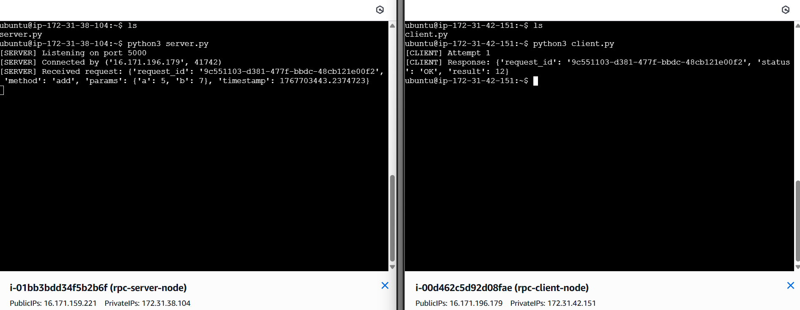
Perform one of:
- Kill server mid-request → client retries
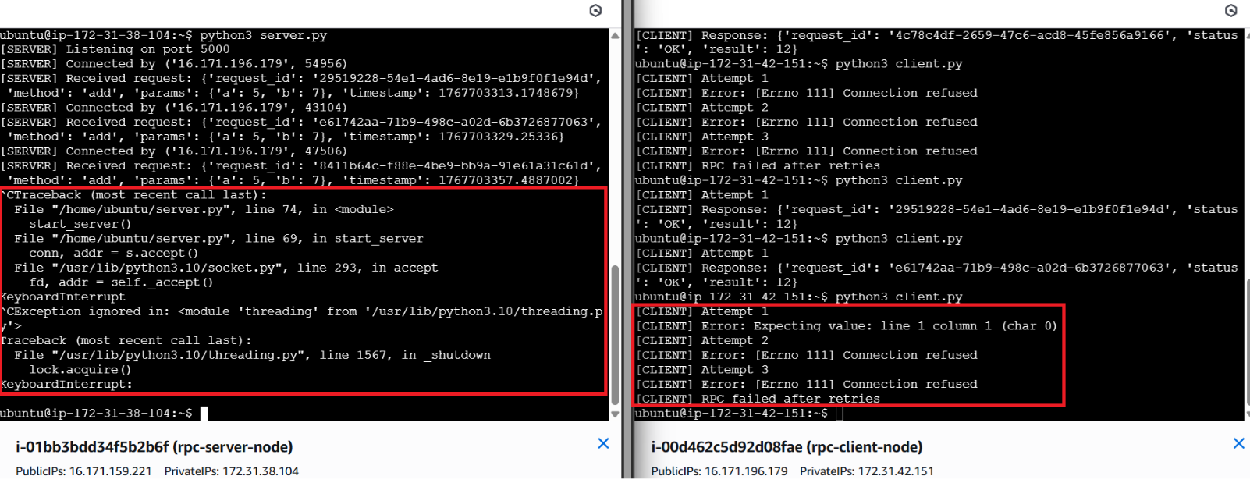
Explanation:
The server was stopped (by Ctrl + C) while it was processing a client request. The client sent an RPC request and waited for a response, but because server crashed, no response was received. After the timeout expired, the client automatically retried the request several times and eventually reported a failure. We achieved at-least-once semantics, as it may be executed one or more times.

